National Real-Time Payments System
1. Overview
The National Real-Time Payments System is designed to enable instant peer-to-peer (P2P) and peer-to-merchant (P2M) transactions on national scale. The platform must support 150 million registered users, 40 million daily active users, and peak loads exceeding 50,000 transactions per second (TPS), while maintaining transaction latency below 2 seconds and availability of 99.999%.
Given the financial criticality of the system, the architecture must prioritize:
- Strong consistency for financial records
- Zero data loss
- Real-time fraud detection without performance degradation
- High availability with no single point of failure
- Regulatory compliance (PCI DSS, ISO 27001, national banking regulations)
- Scalability to handle 10x national event spikes
- Future international interoperability
The following sections outline the required systems, information flows, failure analysis, mitigation strategies, contingency planning, trade-offs, and global benchmarking.
2. Required Systems and Subsystems
2.1 Core Payment Systems
- User onboarding & KYC service
- Account linking & bank account verification service
- Real-time P2P and P2M payment engine
- QR generation & validation service
- Transaction history & ledger service (double-entry ledger)
- Notification service (SMS, push, email)
The payment engine ensures atomic transaction execution and strong ledger consistency.

2.2 Banking & Settlement Systems
- Bank integration gateway (API hub)
- Inter-bank settlement engine
- Reconciliation service
- Scheduled settlement processor
- Chargeback & dispute management service
This layer isolates bank-specific integrations and ensures the system continues functioning during partial bank outages.
2.3 Merchant Systems
- Merchant onboarding & verification
- Merchant dashboard service
- Merchant settlement service
- QR management system
Merchants are treated as first-class participants with dedicated reporting and settlement capabilities.
2.4 Risk & Compliance Systems
- Real-time fraud detection engine
- Risk scoring engine (ML-based)
- AML & Compliance Screening
- Audit logging service (append-only)
- Regulatory reporting system
Fraud scoring is optimized to complete within milliseconds and does not delay transaction confirmation.
2.5 Platform & Infrastructure
- API Gateway
- Authentication & authorization service
- Observability stack (monitoring, logging, tracing)
- Distributed cache (Redis/Memcached)
- Message queues (Kafka/PubSub)
- Database clusters (SQL + NoSQL)
- CDN & load balancers
- Disaster recovery & backup systems
This layer ensures horizontal scalability, resilience, and operational visibility.
2.6 Future International Payment Systems
- FX conversion engine
- Cross-border routing service
- International settlement gateway
- Compliance adapters for foreign regulations
The architecture is designed to evolve into a multi-currency, cross-border real-time payment platform.
3. Logical Architecture Diagram
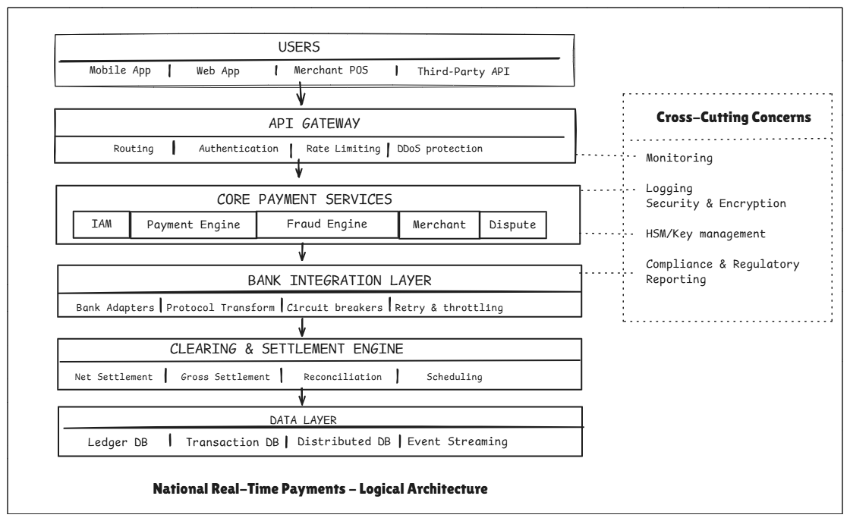
The above image illustrates the layered logical architecture separating channel access, core payment processing, banking integration, settlement, and data persistence. Cross-cutting concerns such as monitoring, security, and compliance apply across all layers.
4. Information Exchanged Between Systems
User ↔ Platform
- KYC data
- Payment instructions (sender, receiver, amount)
- Account linking data
- Transaction status updates
Characteristics: Very high frequency, strict consistency, sub-second response.
Platform ↔ Banks
- Account validation requests
- Debit/credit instructions
- Settlement batch files
- Reconciliation logs
Characteristics: Low latency (<200 ms preferred), high reliability, idempotent operations.
Platform ↔ Merchants
- Payment confirmations
- Refund & chargeback notifications
- Daily settlement reports
Internal Subsystems
- Fraud scoring data (real time)
- Ledger updates
- Event streams for analytics
- Audit logs (high-volume, immutable)
Cross-Border Systems
- Currency rates
- Routing metadata
- Partner bank confirmations

5. Major Potential Failure Points
5.1 Technical Failures
- Payment engine overload
- Database cluster failure
- Cache outage
- Message queue backlog
- Network partition
- Data center outage
5.2 Integration Failures
- Bank API latency or downtime
- Settlement confirmation failures
- Malformed merchant QR data
5.3 External Dependency Failures
- SMS gateway downtime
- Third-party KYC provider failure
- National ID system outage
- FX rate provider outage
6. Mitigation Strategies
Redundancy & High Availability
- Multi-region, multi-availability zone deployment
- Active-active data centers
- Synchronous ledger replication
- Hot-standby bank connectors
Failure Isolation
- Circuit breakers per bank
- Bulkhead isolation between services
- Retry with exponential backoff
- Graceful degradation of non-critical services
Performance Controls
- Distributed caching
- Write-ahead logging for durability
- Asynchronous processing for heavy workloads
- Auto-scaling compute nodes
Security Controls
- HSM-backed encryption
- Tokenization of sensitive data
- Continuous fraud model monitoring
7. Contingency Plans
Payment-Level
- Deferred processing when banks are unavailable
- Queued transactions with scheduled retries
- Backup routing where available
- Clear user communication for pending status
Settlement-Level
- Manual reconciliation workflows
- Temporary settlement window extensions
- Offline batch processing capability
Platform-Level
- Traffic rerouting to secondary regions
- Rollback to last consistent checkpoint
- Controlled fraud-rule relaxation during critical outages
User Communication
- Real-time outage notifications
- Transparent transaction status
- Merchant & bank dashboard alerts

8. System Behavior Under Load
Normal Daily Load
- Full real-time fraud checks
- Synchronous bank calls
- Standard quorum writes
- Minimal queuing
Peak National Events (10x Load)
- Aggressive auto-scaling
- Increased caching of merchant & account metadata
- Adaptive fraud thresholds
- Asynchronous processing for reporting & analytics
- Load shedding for low-priority traffic
- Pre-warming infrastructure ahead of expected spikes
9. Architectural Trade-offs
Consistency vs Availability
Ledger operations require strong consistency. User-facing status may temporarily show “pending” to preserve availability.
Cost vs Reliability
Active-active multi-region increases cost but is essential for national infrastructure and 99.999% uptime.
Real-Time vs Eventual Processing
Payments must be real-time; reporting, analytics, and settlement can leverage eventual consistency.
Security vs User Experience
Strong authentication (2FA, biometrics) increases friction but significantly reduces systemic fraud risk. Tokenized QR codes minimize user friction.

10. Global Comparison & Unique Differentiators
Global Reference – India UPI
India’s Unified Payments Interface (UPI) is one of the most successful national real-time payment systems globally. It supports high transaction volumes, seamless bank interoperability, and instant peer-to-peer (P2P) and peer-to-merchant (P2M) payments.
Key characteristics of UPI include:
- Instant bank-to-bank transfers
- QR-based merchant payments
- Strong interoperability across banks and fintech providers
- High scalability during peak transaction periods
- Centralized settlement and reconciliation framework
UPI demonstrates that a well-architected real-time payment system can scale nationally while maintaining reliability and security.
Awareness of Other Global Implementations
Other countries have implemented similar real-time payment infrastructures, such as:
- UK Faster Payments
- Brazil PIX
- US FedNow
These systems also provide instant domestic payments with varying settlement models, regulatory frameworks, and integration mechanisms. While implementation approaches differ, the common objectives are high availability, real-time processing, and financial interoperability.
Unique Differentiators of the Proposed Architecture
Compared to existing global systems, the proposed architecture introduces the following enhancements:
- Active-active multi-region deployment to achieve 99.999% availability
- Intelligent bank health-based routing to reduce transaction failures
- Real-time fraud detection optimized to avoid transaction delays
- Built-in cross-border readiness with FX and compliance adapters
- High-speed regulatory analytics dashboard for real-time oversight
- Offline-first merchant capability for low-connectivity environments
These features strengthen system resilience, scalability, and regulatory transparency beyond baseline real-time payment capabilities.
Impact and ROI
The proposed enhancements generate measurable value:
- Reduced transaction failure rates through adaptive routing
- Lower fraud losses via advanced risk scoring
- Increased financial inclusion through merchant accessibility
- Faster regulatory reporting and compliance
- New revenue opportunities through cross-border and data-driven services
Conclusion
The proposed architecture balances scalability, financial consistency, resilience, and regulatory compliance while enabling real-time transaction processing at national scale. By modularizing responsibilities, isolating failure domains, and designing for peak-load elasticity, the system is positioned to become a reliable national payment backbone with future global interoperability.
The design ensures strong financial integrity while maintaining system resilience under extreme concurrency and peak national load conditions.

